RUDA Property & Administrative Management System
Property Management | Applications | Payments | Offerings | User Management | Role Permissions

Project Overview
Built a centralized administrative management system for Ravi Urban Development Authority (RUDA) to manage property operations, applications, offerings, payment plans, users, and internal administration.
The platform provides a single dashboard for monitoring key operational data and managing different administrative workflows.
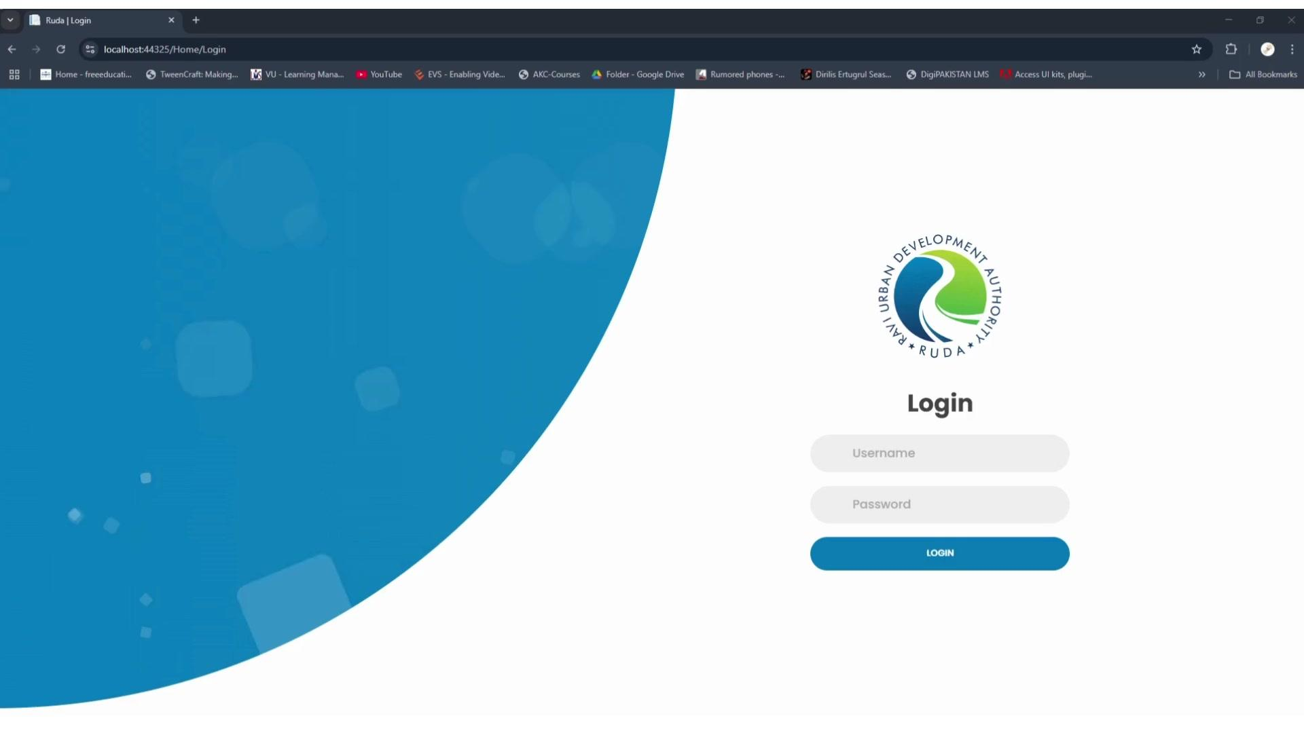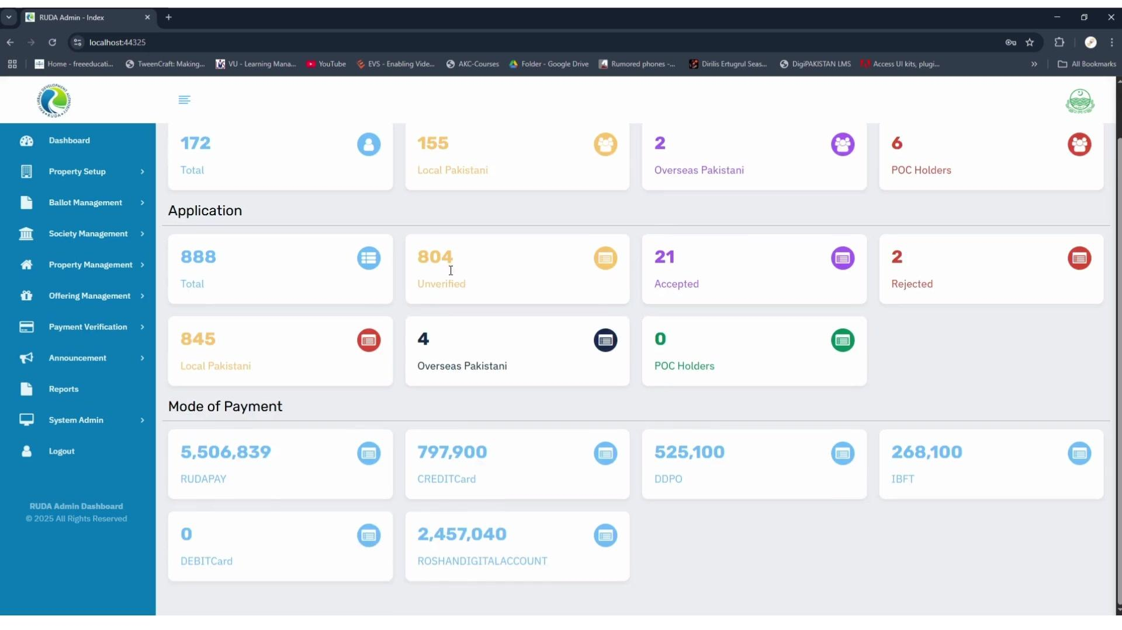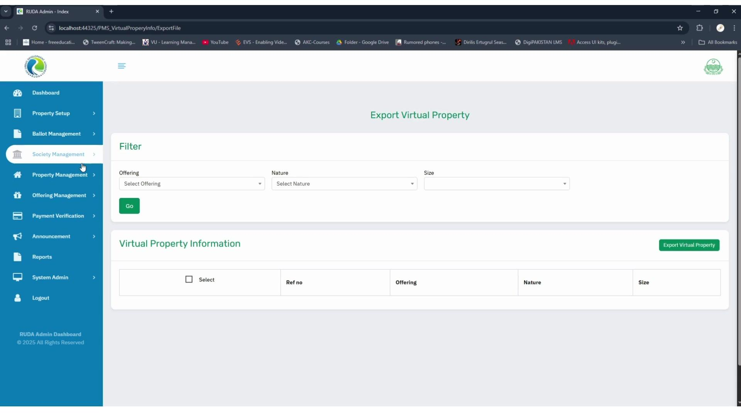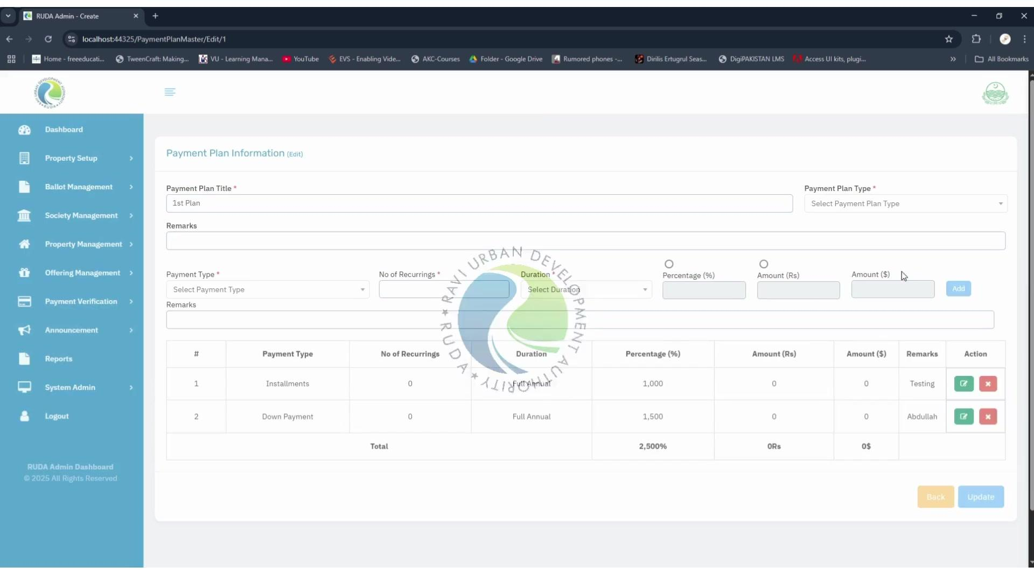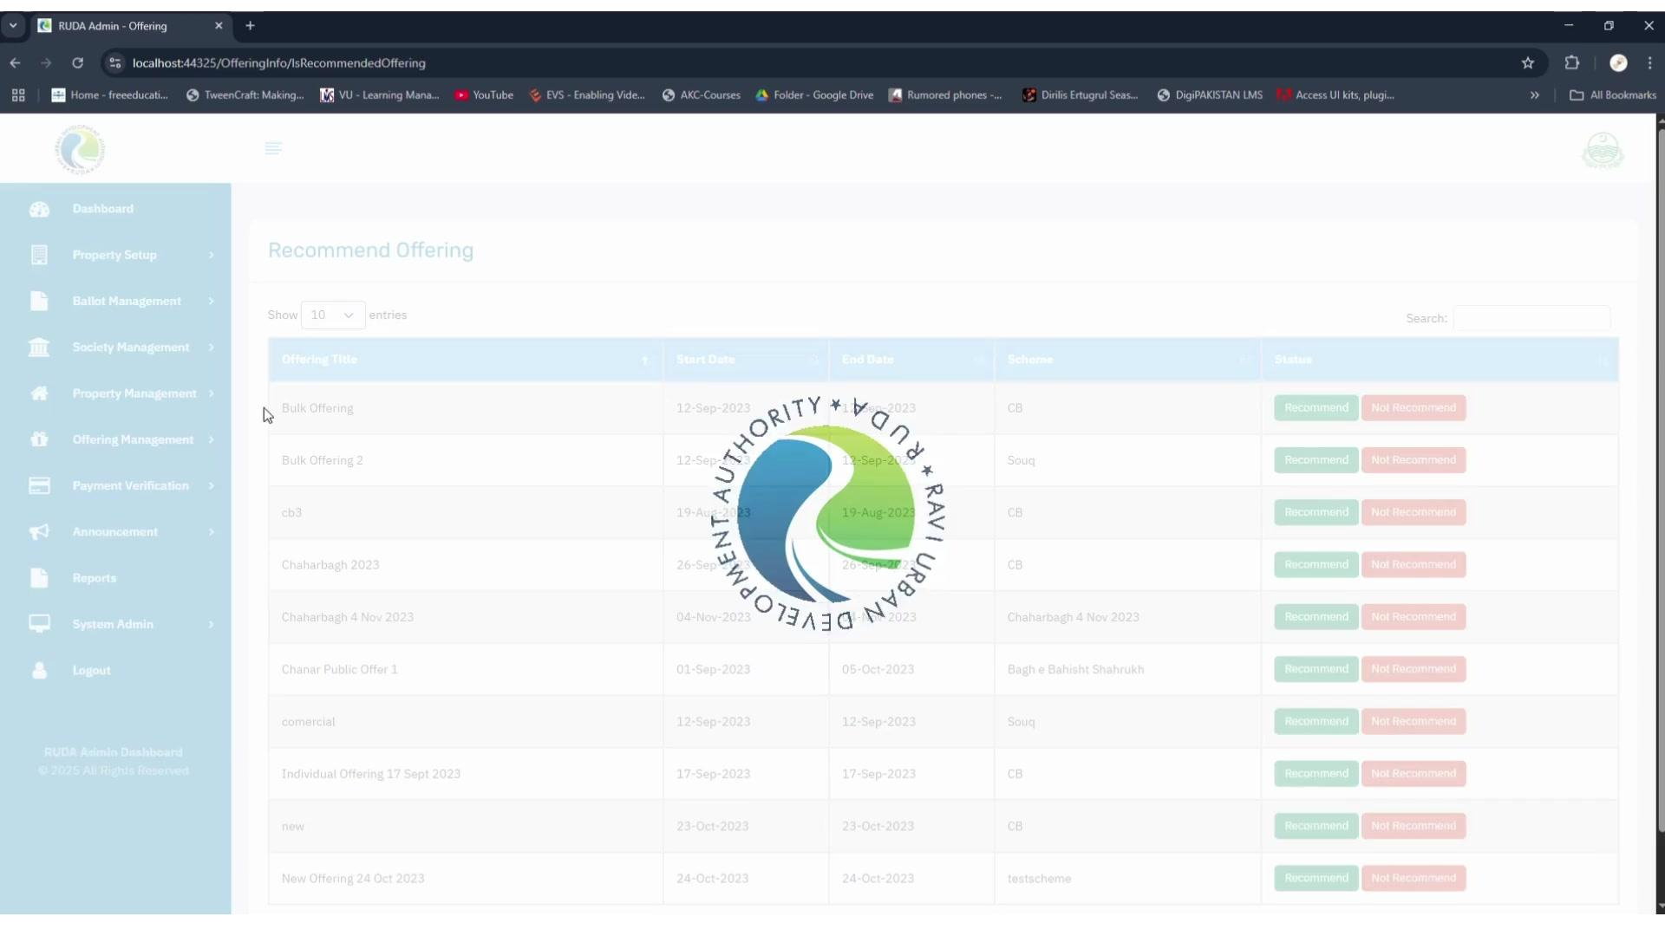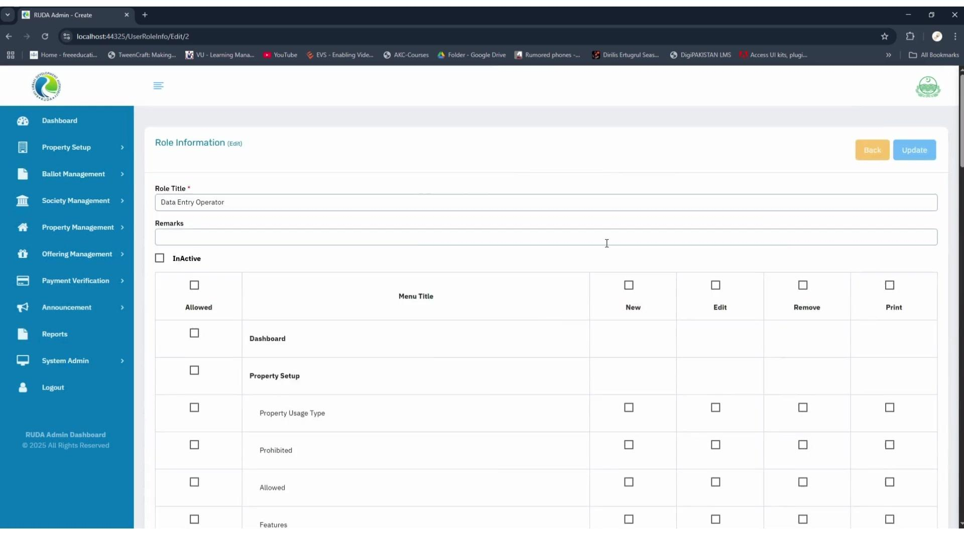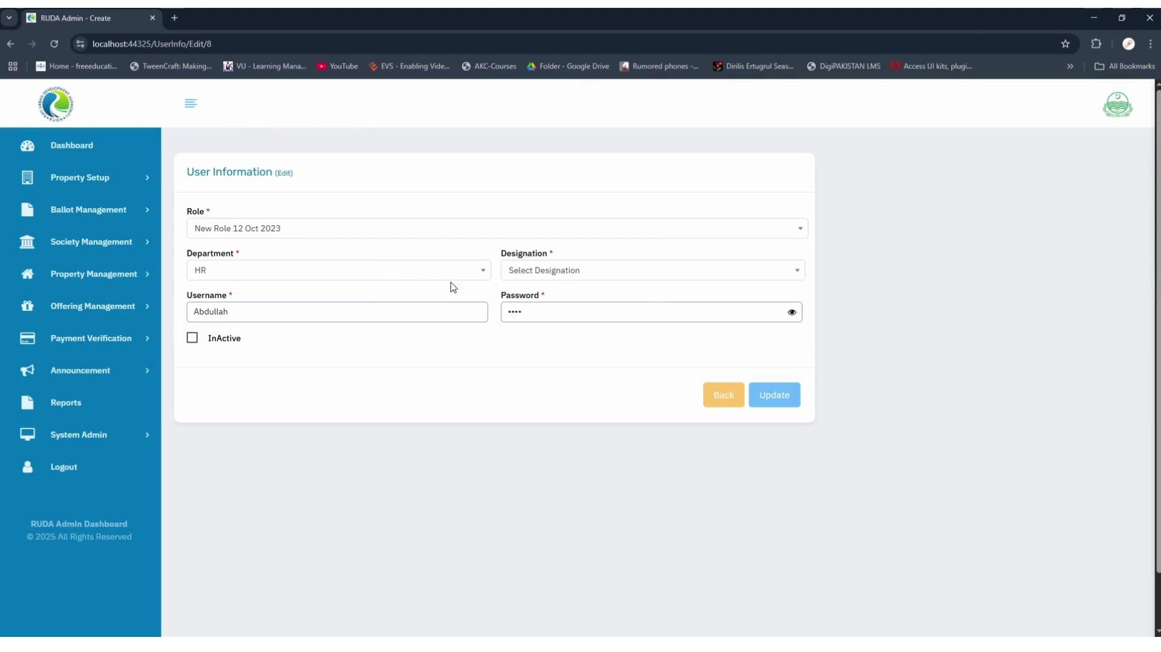

Main Modules
The system includes:
• Dashboard and application statistics
• Property Setup
• Ballot Management
• Society Management
• Property Management
• Offering Management
• Payment Verification
• Announcements
• Reports
• System Administration

Dashboard
The main dashboard provides an overview of:
• Total applicants
• Local Pakistani applicants
• Overseas Pakistani applicants
• POC holders
• Total applications
• Unverified applications
• Accepted applications
• Rejected applications
• Payment totals by payment method

Property Management
The system includes tools for managing and exporting virtual property records.
Administrators can filter properties by:
• Offering
• Nature
• Size
Selected properties can then be exported directly from the system.

Offering Management
The offering section allows administrators to review available offerings and make decisions using:
• Offering title
• Start date
• End date
• Scheme
• Recommend
• Not Recommend

Payment Plan Management
The payment plan module allows administrators to configure:
• Payment types
• Down payments
• Installments
• Recurring payments
• Payment duration
• Percentage based payments
• Amounts in Rupees
• Amounts in Dollars
• Payment remarks
Payment components can also be added, edited, removed, and reviewed through the payment plan table.

User & Role Management
The system includes role based access management where administrators can control:
• User roles
• Departments
• Designations
• Account status
• Module access
• Create permissions
• Edit permissions
• Remove permissions
• Print permissions
This allows different users to have different levels of access across the system.

Key Features
• Centralized administration
• Application status tracking
• Applicant classification
• Payment monitoring
• Property filtering and export
• Offering recommendations
• Payment plan configuration
• User management
• Role based permissions
• Search and filtering
• Structured data tables
• Dashboard reporting

Result
A centralized administrative platform that brings property management, application processing, payment administration, offering management, and user access control into one system.
The dashboard gives administrators a clear view of operational data while dedicated modules provide the tools needed to manage day to day activities.

